Project Report for MBSD :

**Automatic Plant Watering System using Arduino UNO and Soil Sensor**



**CSE L: MBSD LAB**

Submitted By:

Muhammad Maaz (22PWCSE2204)

Muhammad Talha Khan (22PWCSE2213)

Muhammad Ibad Khan (22PWCSE2170)

Section: A

Submitted to : Engr . Fahim Jan

Department of Computer Systems Engineering

University of Engineering and Technology Peshawar

PROJECT REPORT

**INTRODUCTION:**

An automated plant watering system eliminates the need for manual monitoring and ensures that plants receive adequate water based on soil moisture levels.

This project proposes the development of an Automatic Plant Watering System using Arduino UNO, a soil moisture sensor, and a relay-controlled water pump, which will automate irrigation based on real-time soil moisture data**.**

**Objectives**

* To design and implement a smart irrigation system that automatically waters plants when the soil becomes dry.
* To reduce water wastage through precise control.
* To create a low-cost, energy-efficient, and scalable system suitable for home gardens or small-scale farms

**Components:**

* Arduino UNO
* Soil Moisture Sensor
* 1-Channel Relay Module
* Mini Water Pump (5V or 12V) including mini pipe.
* Jumper Wires
* Power Source (5V or 12V battery/adapter)

**Working Principle**

* The soil moisture sensor continuously reads the soil moisture level.
* The sensor sends analog data to the Arduino UNO, which processes the value.
* If the moisture is below a defined threshold, the Arduino activates the relay, turning on the water pump.
* Water is pumped into the soil for a defined time or until the moisture level becomes sufficient.
* When the moisture level returns to normal, the Arduino deactivates the relay, stopping the water pump.

**Applications**

* Home gardening automation
* Greenhouses and indoor plant management
* Urban farming systems
* Smart agriculture prototypes

**CODE:**

int water; //random variable

void setup() {

pinMode(3,OUTPUT); //output pin for relay board, this will sent signal to the relay

pinMode(6,INPUT); //input pin coming from soil sensor

}

void loop() {

water = digitalRead(6); // reading the coming signal from the soil sensor

if(water == HIGH) // if water level is full then cut the relay

{

digitalWrite(3,LOW); // low is to cut the relay

}

else

{

digitalWrite(3,HIGH); //high to continue proving signal and water supply

}

delay(400);

}

**CIRCUIT DIAGRAM:**

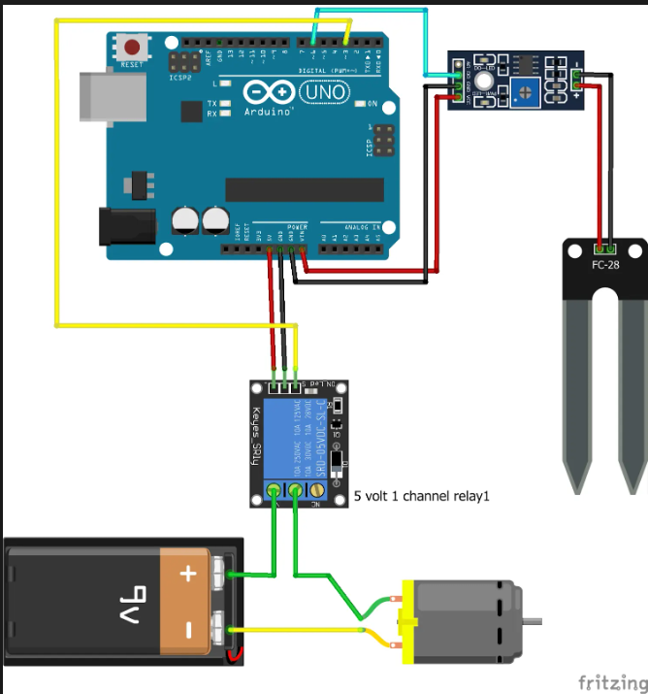

**CIRCUIT OUTPUT:**

**Conclusion:**

This project successfully automates plant watering using Arduino, ensuring optimal soil moisture levels. It is cost-effective, efficient, and scalable for various applications.

THE END